


THE REAL SCHOOL
LEARNER’S EMPOWERMENT ACTIVITIES
P.6 TERM I 2026 INTEGRATED SCIENCE
SOUND ENERGY

Victoria P/S

Golden Junior
School

Makindye Junior School

An excellent first grade and excellent character for every pupil

NAME………………………………………………………………………CLASS: …………………………
SCHOOL: ……………………………………………………………………………………………………….
THEME: MATTER AND ENERGY
TOPIC: SOUND ENERGY
EDITED LEARNERS EMOWERMENT ACTIVITIES FOR 2026.
DIAGRAM OF A PERSON PLAYING A GUITAR

What I will be able to understand: I……………………………… will be able to understand sound energy and its uses.

How I will be able to apply the learnt competences in my daily life.

I will be able to use sound to solve my daily life challenges.

SESSION ONE
I will be able to understand and answer the following questions at the end of my session.
1.To which group of musical instruments does a saxophone belong?

2.How does a drum produce sound?

3.How can the pitch of sound produced by a flute be varied?

4.Why is sound unable to travel through a vacuum?

5.Why are cinema halls covered with soft porous materials?

WHAT I ALREADY KNOW.
Heat energy.
Types of thermometers.
Draw a clinical thermometer and label its parts.

MY LESSON VOCABULARY
Thunder - waterfall -animals – wind -earthquake - rain.
I CAN TRY THIS.

State any two natural sources of sound in the environment.
I)…………………
II)……………….
LET ME ENJOY MY LEARNING PHASE ONE (1).
I will be able to understand sound and the applications of sound in my daily life.
SOUND ENERGY
Sound is a form of …………… produced by vibration of an ……………. (Object, energy)
Sound is regarded ad a form of energy because it enables people to do work.
WHAT CAN ENABLE ME TO UNDERSTAND THIS
- Sound means - a form of energy produced by vibration of an object.

I will be able to state the properties of sound
Properties of sound.
- Sound can be reflected.
DIAGRAM SHOWING REFLECTION OF SOUND

- Sound can be refracted.
- Sound can be stored and produced.

I ……………. will be able to give types of sound.
Types of sound
●Loud sound ●……………. ●High sound
●Soft sound ●……………. ●…………………..
Music
What can enable me to understand key terms (K.L.P)
- Music → an organized sound.
- Music is an organized sound produces by regular vibrations.
- Noise: → Disorganized sound produced by irregular vibration.

I ………………… will be able to give the uses of sound

Uses of sound as a form of energy.
K.L.P: Energy →Ability to do work.
- Sound is used for communication
- …………………………………………………………………..
I will be able to state the types of sources of sound in the environment.
Types of sound.

I)Natural sources of sound II) ………………………………. …

I will be able to state the artificial sources of sound

Examples of artificial sources of sound.

DIAGRAM OF A RADIO | DIAGRAM OF A BELL | DIAGRAM OF GUITAR | DIAGRAM OF A TUBE FIDDLE. | DIAGRAM OF PIANO

Mini activity
1. Give the meaning of the term sound.
____________________________________________________________________________
2. State any two types of sound.
i) __________________________________ ii) ______________________________________
3. How do mammals produce sound?
____________________________________________________________________________
4. Write down any three properties of sound.
i) __________________________________________________________________________
ii) __________________________________________________________________________
iii) _________________________________________________________________________
5. Give any two types of sources of sound.
i) __________________________________ ii) ______________________________________
6. Briefly explain the term music.
________________________________________________________________________________________________________________________________________________________
7. State any three examples of natural sources of sound.
i) _________________________________ ii) _______________________________________
8. In the space provided below draw an example of artificial sources of sound.

9. Give the meaning of noise.
____________________________________________________________________________
10. Why is sound referred to as a form energy?
____________________________________________________________________________
11. Write down any two uses of sound.
i) __________________________________________________________________________
ii) __________________________________________________________________________

LET ME ALSO ENJOY MY LEARNING PHASE TWO

I will be able to describe musical instruments and different groups of musical instruments.

WHAT IS GOING TO ENABLE ME TO UNDERSTAND THIS PHASE.

- Musical instruments – means devices played to produce sound

- Percussion musical instruments – Produce sound by vibration of their surfaces when hit.

- Wind musical instruments- produce sound by vibration of air molecules blown in them.

- String musical instruments- produce sound by vibration of strings when plucked.

CONTENT/LESSON
MUSICAL INSTRUMENTS.
What will enable me understand musical instruments.
- These are materials used to produce sound.
- I ……………………. will be able to describe different groups of musical instruments like
- Wind instruments

- String instruments

- ……………………………….

I will be able to describe percussion musical instruments.

Percussion musical instruments
These are musical instruments which produce sound by vibration when hit or beaten.
Examples of percussion instruments.
- Xylophones
- ……………………
- Thumb pianos
- Long drum
- ………………………
- Clappers
- Shakers
- ……………………….

I ………………. Will be able to describe how different percussion instruments produce sound.
How different percussion instruments produce sound.
- A drum produces sound by vibration of their surface when hit.
- Shakers produce sound by vibration of their surface when struck.
- Xylophones also produce sound by striking them to vibrate.

I will be able to draw and name different percussion musical instruments.
Diagram showing different examples of percussion
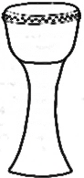
A long drum | ………………………. | Xylophones | …………………
 | 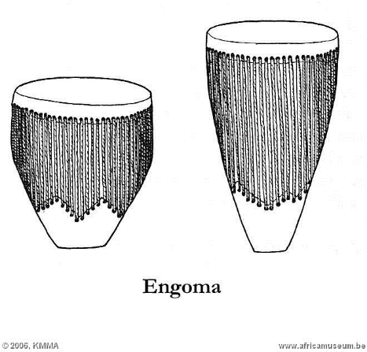 | 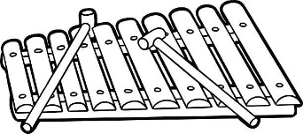 | 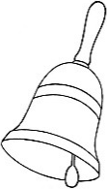

I WILL ……………………… BE ABLE TO DESCRIBE WIND MISICAL INSTRUMENTS

Wind instrument
These are musical instrument which produce sound by the ………………. of air blown inside them. (vibrates, vibration)
Some have holes numbered to produce different pitch of sound.

I …………………..will be able to state examples of wind musical instruments.
Examples of wind musical instruments.
*A flute *Empty bottles
*………………..

I)………………… *Saxophone

*Panpipes
I…………..WILL BE ABLE TO NAME SOME WIND MUSICAL ISTRUMENTS

Diagrams of some musical instruments.
Saxophone | ………. | Trumpet | A French horn
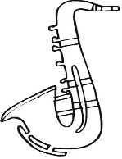 | 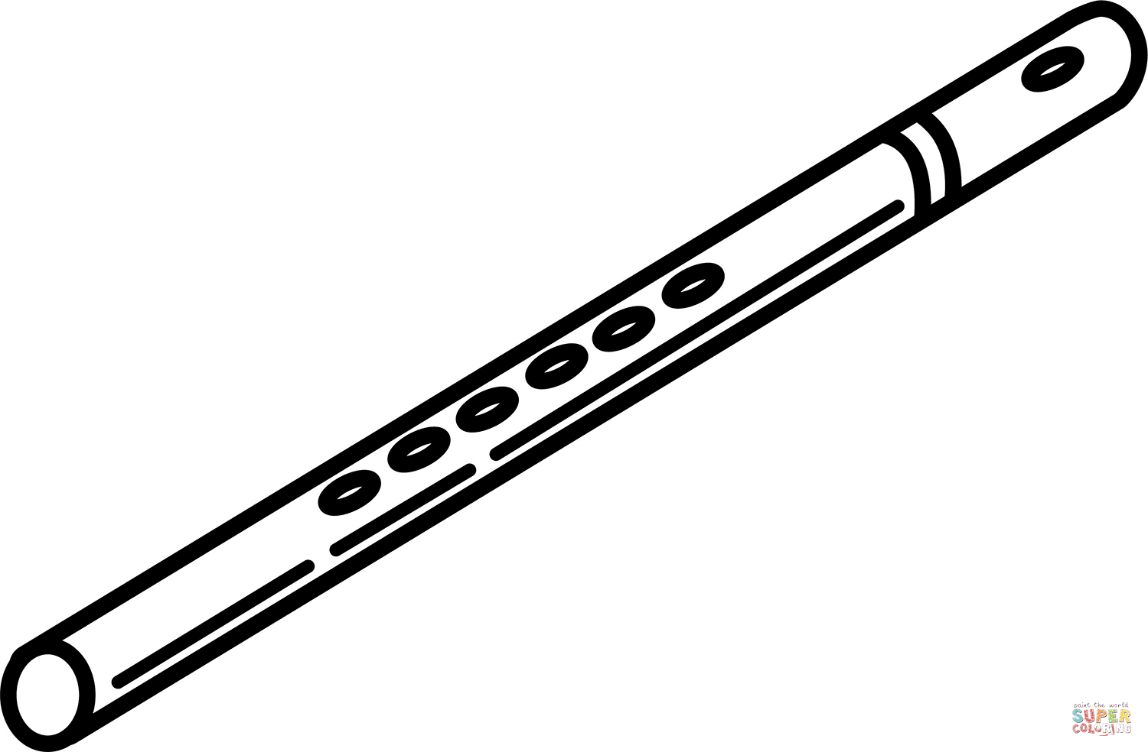 | 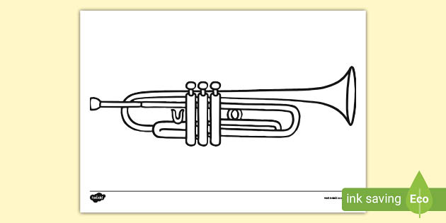 | 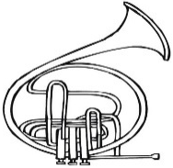
String musical instruments (chordophones)
- These are instruments made of strings.
- They produce sound by vibration of the strings when they are plucked/bowed.

I ……………….will be able to give examples of string musical instuments.

Examples of string musical instruments.
-Guitar -Lure II) ……………….
-Tube fiddle I) ………………….
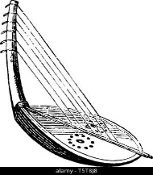
Diagrams showing other examples of string instruments.
A violin | Bow harp (Adungu) | ………………
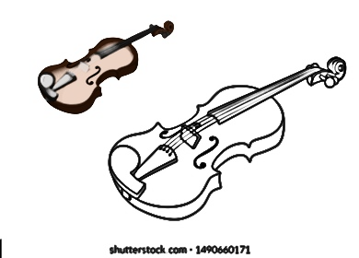 |  | 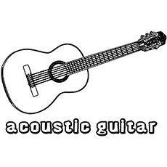

MEGA ACTIVITY
1. State any two ways how different percussion instruments produce sound.
i) __________________________________________________________________________
ii) __________________________________________________________________________
2. Give three examples of wind musical instruments
i) _____________________ii) _______________________iii) _________________________
3. Write down any three examples of percussion instruments.
i) _____________________ii) _______________________iii) _________________________
4. Give one reason why different wind musical instruments have different holes.
____________________________________________________________________________
5. How does a drum produce sound?
____________________________________________________________________________
6. What makes a flute to be grouped among wind instruments?
____________________________________________________________________________
7. Why are strings of a bow harp have different length?
____________________________________________________________________________
8. What is wind musical instruments?
____________________________________________________________________________
9. Give the difference between percussion and string musical instruments.
____________________________________________________________________________
____________________________________________________________________________
10. Why are drums always exposed to sunshine before they are played?
____________________________________________________________________________
11. In the space provided below, draw and name any one example of percussion instruments.

_____________________________

12 Why are guitar strings metallic?
____________________________________________________________________________

SESSION TWO
I will be able to answer these questions at the end of my session.

1.Give the meaning of the term pitch of sound.

2.State any two factors that determine pitch of sound.

3.Describe an experiment to show that sound travels in solids. (3 marks).

WHAT I ALREADY KNOW.

How can the pitch of sound produced by a flute be varied?

CONTENT/LESSON

I……………. will be able to describe how sound travels.

How sound travels.
- Sound travels by means of sound waves.
- Sound eaves in all directions from a vibrating object but become weaker as they
move away from the vibrating object.
Speed of sound
Sound travels fastest in solids, faster in liquids and fast in gases.
Speed of sound in the three states of matter.
i) Solids (iron) → 1500m/sec
ii) Liquids (water) →1484m/sec
iii) Gases (air) →330m/sec.
Factors affecting the speed of sound.
i) TEMPERATURE/HEAT
The speed of sound increases with increase in temperature.
ii) Wind
The speed of wind increases/decrease according to the direction of wind.
If wind is blowing in the direction of sound, the speed of sound increases, if it is blowing in a direction opposite to that of sound, the speed of sound decreases.
iii) Altitude
The speed of sound decreases with increasing altitude.
Sound waves move easily along a lower altitude that climbing or going uphill or mountain.
iv) Humidity
The speed of sound in air increases with the increase in humidity in the air. Sound travels in humid air than dry air.
I…………will be ale to describe terms used in sound.

Terms used in sound.
-Echoes -Frequency -Pitch -Volume

I will be able to state the advantages of echoes.

Advantages of echoes.
- Bats use echoes to locate food at night.
- Blind people use echolocation to avoid obstacles.
- Whales use echoes to know obstacles.
- Pilots use echoes from hills and mountains to avoid accidents.
- Fisher men use echoes to locate schools of fish in water.

I…………. will be able to give the disadvantages of echoes.
Disadvantages of echoes.
- Echoes make sound difficult to interpret.
- Echoes cause accidents and noise pollution.
- Echoes cause un necessary noise in music studios and cinema halls.

I………………will be able to describe how echoes can be reduced in cinema halls.

How echoes are reduced in cinema halls and theatres.
- By putting soft boards on the walls.
- Using thick curtains on the wall.
- Covering walls with soft porous materials.
- Using thick carpets on the floor to absorb sound waves.

I will be able to calculate distance and time

Calculating distance and time.
Using speed of sound
A man heard a gunshot after four minutes. How far is he from the firing spot?
Time= 4sec
D = S×T
=330mls ×4s
= 1320m
Volume of sound
- Volume is the loudness or softness of sound
- The volume of sound depends on the amplitude of the vibration produced.
- The greater the amplitude the louder the volume of sound and the smaller the amplitude the softer the volume of sound.
Frequency
- Frequency is the number of vibration produced per sound.
- Frequency is measured in hertz.
Diagram showing produced by different strings.
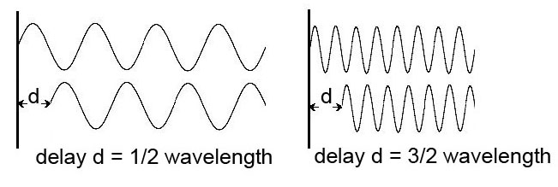
loud sound

High sound

MEGA ACTIVITY
1. Give the meaning of echoes.
___________________________________________________________________________
2. Give one incident that can lead to formation of an echo.
___________________________________________________________________________
3. State any two advantages of echoes in the environment.
i) _________________________________________________________________________
ii) _________________________________________________________________________
4. Apart from bats, give two other examples of animals that uses echo location.
i) __________________________________ ii)_____________________________________
5. Identify the state of matter in which sound travel slowest.
___________________________________________________________________________
6. Give a reason to support your answer in (6) above.
___________________________________________________________________________
7. Why are cinema halls covered with soft porous materials?
___________________________________________________________________________
8. How are sounds produced?
___________________________________________________________________________
9/ Give one similarity between sound and heat energy.
___________________________________________________________________________
10. If the plane was seen 4 seconds its sound was heard, calculate the distance it had travelled (sped of sound in air in 33m/sec)

11. Give any one environment echoes in the environment.
___________________________________________________________________________
12. State any three factors that affect the speed of sound.
i) _________________________________________________________________________
ii) _________________________________________________________________________
iii) ________________________________________________________________________
SESSION THREE

I will be able to answer these questions after understanding my session.

1.Give the meaning of the term frequency.

2.Name the body organ that helps in balancing of the human body.

3.State two diseases of the human ear.

What I already know.

1.How is sound important in our daily life?

CONTENT/LESSON

What is going to help me understand this.

Pitch is the highness or lowness of sound.
I………. will be able to describe factors that affect pitch of sound.
Factors that affect the pitch of sound.
i) Frequency
ii) Tension of the vibrating materials.
iii) ……………………………………..
iv) Size/surface of the vibrating object.
v) ………………………………………
vi) Thickness of the vibrating material.
a) Size of the vibrating material.
Smaller sized objects produce pitched sound while a big one produces low pitched sound.
A
B
C
drums of different sizes.

Observation
Drum A: will produce sound of the highest pitch because it has a small vibrating surface.
Drum B: produced low pitched sound.
Drum C: will produce the lowest pitched sound because it has a big vibrating surface.
Tension in the vibrating material.
(Tightness or looseness)
A tight object produces a higher pitch while a loose object produces a low-pitched sound.
Frequency of the vibration
Quick vibrations produce high frequency and therefore produce high pitch of sound and low vibration produces low pitch.
Hight frequency produces low pitched sound.
Nature of the vibrating material.
The type of material used determination the pitch of sound.
Length of vibrating object.
Low strings produce low pitched sound while short ones produce high pitched sound.
Ways of string and reproducing sound.
-Mechanical method -Electromagnetic method -Magnetic
Devices used in string sound.
- Video compact tapes.
- Compact discs
- Digital video discs.
- Video compact discs (VCDs)
- Computer diskettes.
- Flash disks.
Reproducing sound
Sound can be reproduced by playing the recorded sound using different devices,
Devices used to reproduce the stored sound.
- Radio cassette players -Video decks
- DVD player -Video desks
- Record players -MP4 player, mobile phones
Diagrams

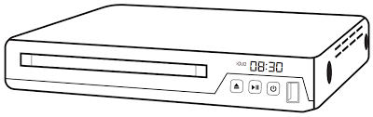

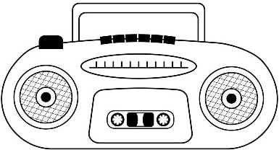

MEGA ACTIVITY
1. Give any two ways of strong sound.
i) _________________________________________________________________________
ii) ________________________________________________________________________
2. Mention any three devices used to store sound.
i) ______________________ ii) ____________________ iii) _________________________
3. Give two ways how sound can be reproduced.
i) _________________________________________________________________________
ii) ________________________________________________________________________
4. Give the meaning of volume of sound.
______________________________________________________________________________________________________________________________________________________
5. State one factor that determine the volume of sound.
___________________________________________________________________________
6. What do you understand by the following terms as used in sound?
i) Pitch ____________________________________________________________________
ii) Frequency ______________________________________________________________
7. How does frequency affect the pitch of sound?
___________________________________________________________________________
8. State any one way how one can pitch sound of an object.
___________________________________________________________________________
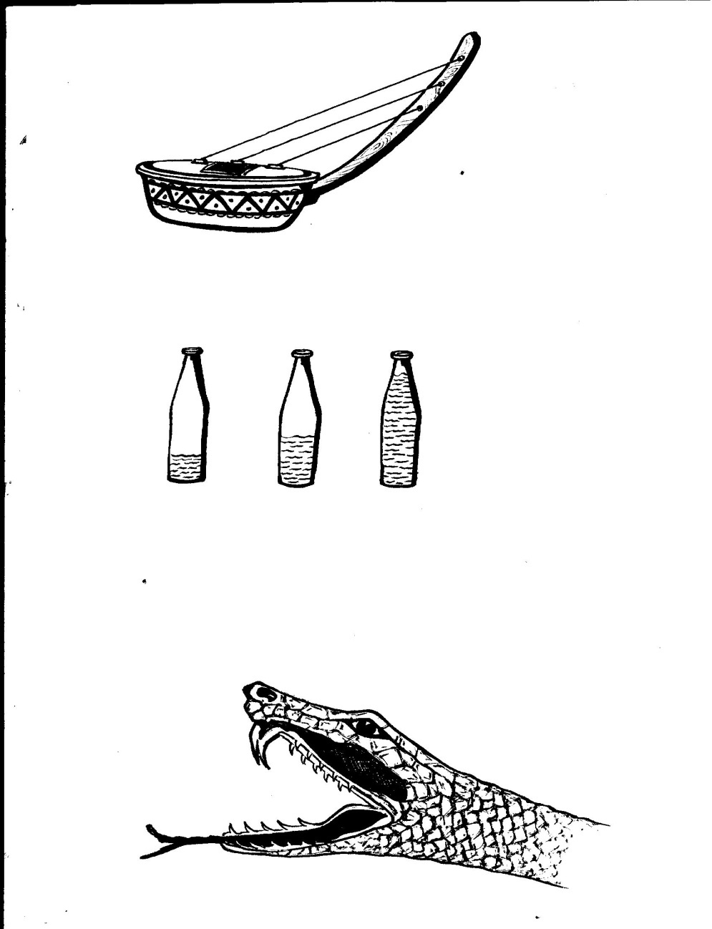
9. The diagram below shows a music instrument. Study and use it to answer questions that follow.
C
D
B
A

- Name the music instrument above.
___________________________________________________________________________
- Which of the strings produce the highest pitch o sound?
___________________________________________________________________________
c) Give a reason to support your answer in (b) above.
___________________________________________________________________________

SESSION FOUR
I……………….will be able to answer these questions at the end of my session.

1.Which part of the human ear amplifies sound vibrations?

2.Describe the hearing process in humans (4 marks)
WHAT I ALREADY KNOW.

State the ways of reproducing sound stored by the following methods:

I) Mechanical method.

II)Magnetic method.

III)Electromagnetic method.

CONTENT/LESSON

the human ear

I………………..will be able to describe the parts of the human ear .
The human ear is a sensory organ used for hearing sound.
The ear also helps in balancing the body in the right position.
Diagram showing the parts of the human ear.
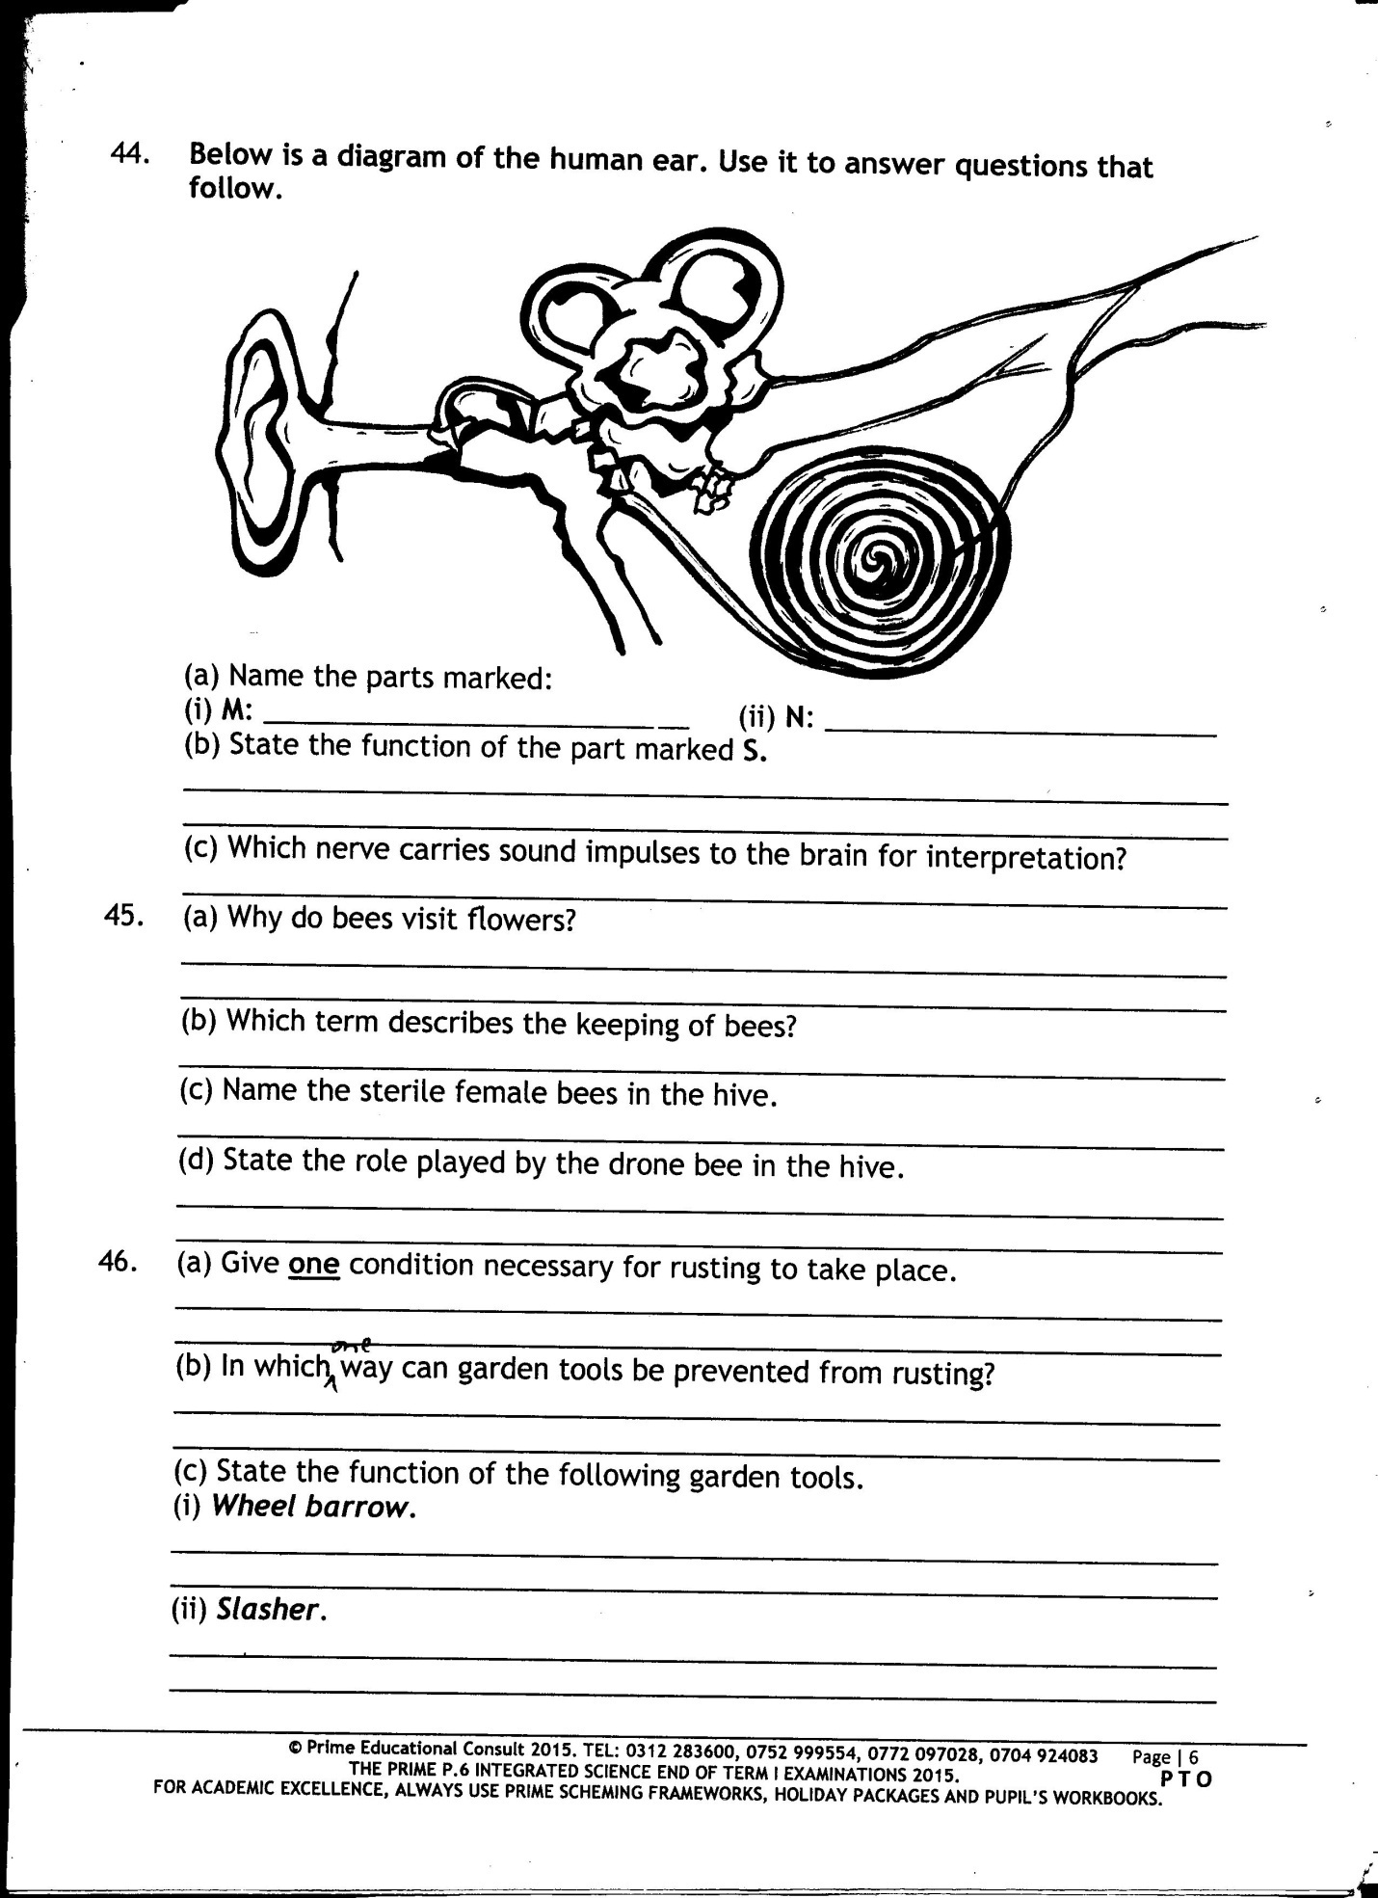
pinna
auditory canal
ear drum
auditory nerves
cochlea
semicircular canals
Eustachian tube
Ossicles

I……………….will be able to state the functions of each part of the human ear.
Functions of parts of the ear.
Pinna → Collects sound waves from the environment and sends it to the auditory canal.
Auditory canal → Directs sound waves to the ear drum making it to vibrate.
Ear drum → It changes sound wavs into vibrations and transmits the sound vibrations to the ossicles in the middle ear.
Ossicles → These amplify and transmit sound vibrations from the three bones in their order.
Eustachian tube →It balances the air pressure between the ear and atmospheric pressure.
Cochlea → It converts sound vibration into impulses/never messages.
The semi → Circular cahals These help to balance the body in a right posture.
Auditory nerve → Helps to carry sound impulses/messages to the brain for interpretation.
Diseases of the human ear
K.L.P
Disease → The state of the body being un healthy.

I ………………. Will be able state diseases of the human ear.

Diseases of the human ear
>Otitis >Otitis externs >Herpes zoster of the ear.
>Discharging ears >Ringing ears >Boils in the ears
>Otalgia/ear ache.
Symptoms of a sick ear.
- Rise in temperature.
- Painful ear.
I will be able to state the disorders of the human ear.

Disorders of the human ear.
♦Foreign body in the ear e.g. seeds, soil, insects, chemicals etc.
♦Deafness ♦Ear ♦…………. Blockage
♦Ruptured

I…………. will be able to describe different types of deafness.
Types of deafness
K.L.P
Partial →condition in which a person is un able to hear properly.
Correction of partial deafness.
Sensory deafness
Hera an individual is un able to differentiate between sounds.
Factors which causes sensory deafness.
- Old age
- Diseases or injury of the auditory nerve.
- Serious fracture of the skull.
Correction of sensory deafness.
- By good feeding
- Treatment of an infection of the ear as soon as the symptoms are noticed.
Permanent deafness
- This is where a person is totally un able to hear any sound.
- Common in dumb people.
- It can be inherited from parents.
Care for the human ear.
- Feed on a balanced diet to keep healthy.
- Avoid staying near noisy places.
- Treat infections as soon as symptoms are sighted.
- Avoid boxing each other on the ears.
- Clean the ears daily.
MEGA ACTIVITY
1. Give any two methods of storing sound.
i) _________________________________________________________________________
ii) _________________________________________________________________________
2. Mention any three devices used to store sound.
i) _____________________ ii) ________________________ iii) ______________________
3. To what body system do the ear belong?
___________________________________________________________________________
4. State any two ways of caring for the human ear.
i) _________________________________________________________________________
ii) _________________________________________________________________________
5. Give any two disorders of the human ear.
i) _________________________________________________________________________
ii) _________________________________________________________________________
6. Name the immunisable disease that can lead to permanent deafness in humans.
___________________________________________________________________________
7. State any one way how partial deafness can be corrected in human ears.
___________________________________________________________________________
8. Match the organism in A and their respective organs for detecting sound waves in B.
A B
i) Human beings Lateral line
ii) Insects Ears
iii) Snails Antennae
iv) Fish Tentacles
i) Human beings ____________________________________________________________
ii) Insects __________________________________________________________________
iii) Snails __________________________________________________________________
iv) Fish ____________________________________________________________________
9. State any two symptoms of a sick ear.
i) _________________________________________________________________________
ii) _________________________________________________________________________
10. Give the function of the pinna.
___________________________________________________________________________
11. Name the part of the human ear that helps in the body balance.
___________________________________________________________________________
12. How do we call the three short bones of the ear?

13. Name the human body organ used to detect sound vibrations.

14.Why is it not advisable to clean the ears using sharp objects?
___________________________________________________________________________

